7th MEXICO-CANADA ROUNDTABLE

1st International Congress on The Rights of Indigenous People from November 12th to November 13th 2018, Huehuetla, Mexico.

FULL PAPER TEMPLATE
After notification of abstracts’ acceptance, the full paper should be submitted with the following guidelines:
- Main Topic (according to the selected worktable) (Times New Roman 16 pt, bold and centered)
- Headline (Times New Roman 14 pt, bold, centered)
- Authors’ full name in order and their adscription in the institution (Times New Roman 12 pt, italic and right-aligned)
- Name of the insitution and email
- Text (Times New Roman 12 pt,full- justified, interline space)
- Subtitles (Times New Roman 12 pt, in bold and right-aligned)
- Textual quotations must be indented 11pt
- References in APA Format

Instructions:

- Full paper must have between 3500 to 4000 words. Images, tables and references must be included in the corresponding section. Deadline for submission will be September 15th 2018 and must be sent to the same email addresses with the subject “7th roundtable_fullpaper_author(s)_name.

- Save file indicating the number of the worktable you are interested in, followed by underscore, the word “full”, underscore and the last name of the first author
Example:
4_full_Smith.
Full paper submission deadline: October 20th, 2018.

Headline: No longer than 20 words 14pt in bold
Author
Author
Draft

Figure’s format

Figure 1. Map of mexico
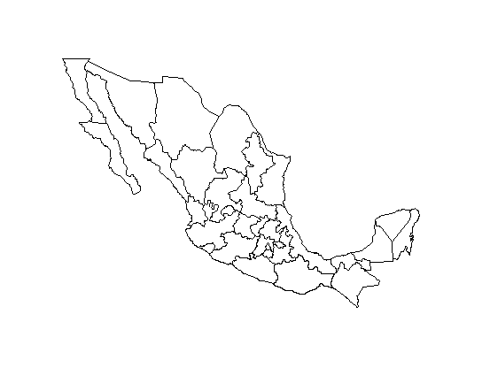
Fuente: INEGI (2012)
Source: INEGI (2012

Table’s Format

Table 1. Example
Column 1 | Column 2 | Column 3 | Column 4
Data | Data | Data | Data
Data | Data | Data | Data
Source:

E-mail and adscription.
E-mail and adscription.

